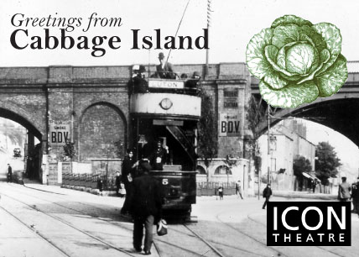

Cabbage Island Local History Resource Notes
These notes are designed to be used alongside the Cabbage Island resource PowerPoint slides. The PowerPoint is 15mb so please email us and we will send you the file!
Together they support an introduction to working as a historian and using local history sources for KS2-3 students, and are based on the question ‘How do we know?’
They can be used in one 60-minute lesson about the history of the Cabbage Island area or can be returned to in a series of a more in-depth then and now study sessions.
The PowerPoint resource presents drawings, photos, maps, census returns and oral history recordings. These notes provide slide-by-slide background information to the historical sources, transcripts of the sound recordings and suggested discussion points and activities. These are repeated in the slide notes. Sound is embedded into the slides.
The suggested activities and questions are a starting point that can be adapted to better suit the requirements of different year groups.
All photos, maps and pages from the census have been licensed for usage by schools using this resource. If you wish to further distribute them or use them in other projects please contact Icon.
For further information, or to request the PowerPoint, please contact Icon Theatre – hello@icontheatre.org.uk
Slide 1 Cabbage Island
Hidden behind the box is a picture clue to the local area name, Cabbage Island. Each click will reveal a piece of the image, five clicks will reveal the whole picture.

Ask questions based on those below and click when you are happy with the answer. At the end ask students to solve the picture clue and tell you the local area name.

- Where are we in the UK today? (aim for Chatham, Medway, Luton or Kent)
- What is the year right now, what century are we in now, what was the last century? (look for understanding of historical language such as decade, century and in the past)
- How can we find out what it was like here [insert answer from Q1] before now? (any sources of information)
- What do we call people who investigate the past? (aim for historian, but could also be archaeologist, detectives, investigators)
- What do you think it was like here in the past? (aim for rural, quiet or not much change)

“Cabbage Island”, Luton
There doesn’t appear to be a definitive reason for the name Cabbage Island and it doesn’t seem to be in common use today. Some of the ideas are that the area was predominately farmland and grew cabbages to feed sailors at the dockyard, and it was at one time cut off by water on all sides. Another idea is that the pattern of underground waterways resembles the veins on a cabbage leaf.
As no-one can say for sure what the right answer is this is a good place to ask students what they think (which can be revisited in the plenary) and to explain that historians base their conclusions on sources of evidence. This leads into the rest of the resource based on ‘How do we know?’
Slide 2 How do we know? A view of Lewton
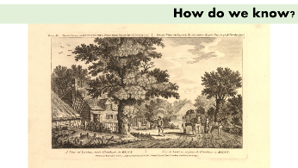
A view of Lewton, c.1770, pencil drawing from ‘Twelve Views in Kent, drawn from Nature’ by J. Cleveley jnr (1747-1786) Titles in English and French. Image ©Trustees of the British Museum

As historians we need to get evidence or clues from more than one place and to build up our picture of the past. Images can be a good place to start.

Does Luton look like this today? What is different? What do you notice? (it is very rural, there is a different spelling of Luton, the title also in French)

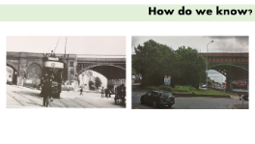
Slide 3 How do we know? Photographs
Left: c.1910 showing an electric tram on its way to the Hen and Chickens pub and a horse and cart. Right: taken in 2018 showing different landscaping.

Photos are really good at showing us what the past looked like, but they are one moment in time.

Is this picture taken from the same place? Does it look like this now? What is the same? What is different? Notice the types of transport, clothing, signage, advertisements

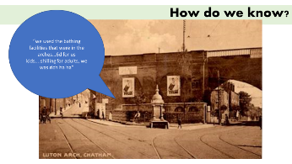
Slide 4 How do we know? Photographs
Luton arch, Chatham, postcard, c1900s, Online at www.chathamhistoricalsoc.btck.co.uk/HistorySection/DriverFountain

This postcard showing Luton arches from the other side to the previous slide. Also showing the Driver fountain, for people and horses, paid for by previous mayor of Chatham Cllr William Dawes Driver (this has been moved to Chatham cemetery). Also note tram tracks, advertisements and public toilets and baths.

Another view of Luton arches, this time from the other side. Use the questioning and noticing skills practised last time to interpret this image. Behind the railings were the public baths that could be used by people who didn’t have a bath at home.

Slide 5 How do we know? Maps
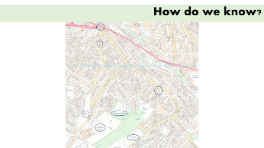
Map showing Luton © Crown copyright and database rights 2014 Ordnance Survey licence number 100024225

We can also use maps to help us find out more. This type of map shows us place names, street names, road layouts, gardens, buildings. We can compare maps made at different times to find out about changes.

Local Luton landmarks are circled: All Saints Primary school, Victory academy (previous name), Luton Primary School, 2 allotments and Millennium Green to help orientate students.

Slide 6: How do we know? Maps

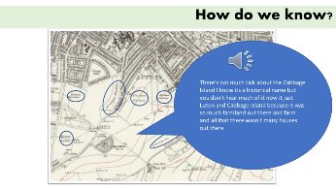
Ordnance Survey map, c.1909, showing Pheasant Farm (and also Pheasant Road for the census slides) and Shorecross Farm, and six allotments
Oral history ©Cabbage Island project

We can use maps to look at place names and how land use has changed or not.

Count how many allotment gardens there are on this map. Why does Chatham need so many?

Click to listen to some oral history about the farms and the name Cabbage Island

Oral history clip “There's not much talk about the Cabbage Island I know it’s a historical name but you don't hear much of it now it just Luton and Cabbage Island because it was so much farmland out there and farm and all that there wasn't many houses out there”

Slide 7: How do we know? Census
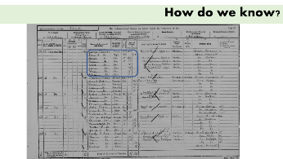
1901 Census of England, Pheasant Row, Chatham, Kent
RG13/730, folio 70, p.5. Digital images, FindMyPast.com (accessed August 2018)

The census is a register of everyone in the country on a particular date. We can use the census to help us find out about the people that lived here in the past, but it is only a snapshot of one day.

Start by reading the headings. This will help us to anticipate answers if the writing is difficult to read. Then read down the column to look for the youngest and oldest people. Try to read their names. [It can help to demonstrate difficult letters on the whiteboard to help read the writing].

Clicking will circle one household at 1 Pheasant Row. How many people live in this house? How old are they? Where were they born? This can be repeated with another household for a comparison.

Slide 8: How do we know? Census
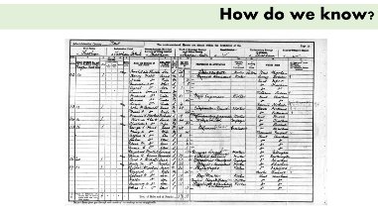
1901 Census of England, Magpie Hall Road, Chatham, Kent
RG13/728, p.18. Digital images, FindMyPast.com (accessed August 2018)

Put your new skills to use and compare this street with the previous one.

Slide 9: How do we know? Oral histories
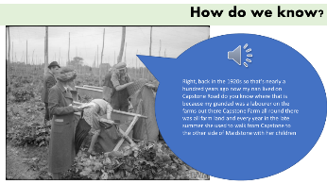
HOPPING IN KENT: HOP-PICKING IN YALDING, KENT, ENGLAND, UK, 1944 © IWM (D 22170)

Oral history ©Cabbage Island project

We can ask people for their memories or their family stories. This is called oral history. The oral histories you’ve been listening to today were collected by students at Victory Academy in 2018.

Oral history transcript: Right, back in the 1920s so that's nearly a hundred years ago now my nan lived on Capstone Road do you know where that is because my grandad was a labourer on the farms out there Capstone Farm all round there was all farm land and every year in the late summer she used to walk from Capstone to the other side of Maidstone with her children

Slide 10: Plenary, Tell it your way
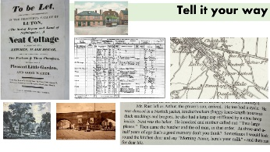
Clockwise left – right: House sale poster, 1800 in Pinn commonplace book (DE284, MALSC); 1901 census, Magpie Hall Road; Hen and Chickens with tram, 1896 map, Extract from Stories from Cabbage Island (Icon Theatre 2018); postcard of Driver fountain; c.1770 A view of Lewton

Split the class into groups and ask each group to select and sort 3 of the sources on screen or from an earlier slide. The selection and sorting could be approached chronologically, type of source, showing continuity or change, or anything else. In turn ask each group to explain their choice.

As an alternative plenary, ask students if they have any other ideas about why the local area has been called Cabbage Island. Designate corners of the room for different theories and ask students to stand in the corner that best represents their opinion.

